**Kazan State Medical University**

**The Department of Foreign Languages**

***continues***

**THE TRANSLATION CONTEST**

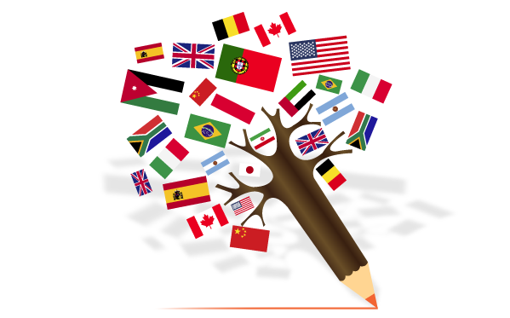

**Asmanova Diana, Eshchenko Aleksandra, Subkhangulova Dinara and Shipakova Adelina move to the next level!!! Congratulation!!!**

**The second level:** You are offered to translate from English into Russian a

poem of **William Carlos Williams *The Birth*.**

The deadline for your **PRINTED** translations is March 23. Please bring it to the Department of Foreign Languages (room #550). Don’t forget to type in your full name, group number, email and phone number!!! Translations without you full name, group number, email and phone number will not be accepted!!!

The results will be announced on our website and in WhatsApp chat.

You can receive the task in the room # 550!

**Good luck!**

**William Carlos Williams**

**THE BIRTH**

A 40 odd year old Para 10

Navarra

or Navatta she didn’t know

uncomplaining

in the little room

where we had been working all night long

dozing off

by 10 or 15 minutes intervals

her great pendulous belly

marked

by contraction rings

under the skin.

No progress.

It was restfully quiet

Approaching dawn on Guinea Hill

in those days.

Wha’s a ma’, Doc?

It do’n wanna come.

That finally roused me.

I got me a strong sheet

wrapped it

tight

around her belly.

When the pains seized her again

the direction

was changed

not

against her own backbone

but downward

toward the exit.

It began to move-stupid

not to have thought of that earlier.

Finally

without a cry out of her

more than a low animal moaning

the head emerged

up to the neck.

It took its own time

rotating.

I thought of a good joke

about an infant

at that moment of its career

and smiled to myself quietly

behind my mask.

I am a feminist.

After a while

I was able

to extract the shoulders

one at a time

a tight fit.

Madonna!

13 $\frac{1}{2}$ pounds!

Not a man among us

can have equaled

that.