Федеральное государственное бюджетное образовательное учреждение высшего образования

"Казанский государственный медицинский университет"

Министерства здравоохранения Российской Федерации

Кафедра госпитальной терапии

**ExaminationcardNo. 1**

1. Differential diagnosis of fever syndrome of unknown origin
2. Pneumonia. Etiology. Pathogenesis. Classification. Clinic. Differentialdiagnosis. Treatment

Заведующая кафедрой, д.м.н. Д.И. Абдулганиева

**Clinical case**

A 25-year-old patient, a driver, was hospitalized with complaints of episodes of suffocation with difficulty exhaling, coughing with difficult-to-separate sputum almost daily. Attacks of suffocation occur 2-3 times a week more often at night and pass spontaneously after an hour with the disappearance of all symptoms. Slight shortness of breath during exercise. He didn't take any medications. Considers himself ill for about 3 months. Since childhood, frequent bronchitis with exacerbations in the spring and autumn periods. Denies other chronic diseases.

There were no operations or injuries. Smokes 1.5 packs a day for 5 years. The mother has bronchial asthma, the father has hypertension. Allergic anamnesis is not burdened. It has no professional harms.

During physical examination: the patient's condition is of a low degree of severity. Body temperature 36.7 °C. The skin is clean, moist. Height 175 cm, weight 81 kg. Peripheral l/nodes are not enlarged. The thyroid gland is not enlarged. The chest is normostenic. On palpation, the chest is painless. RR – 18 per minute. With percussion – a clear sound. The limits of relative dullness of the heart: within normal limits. During auscultation, vesicular breathing is carried out in all departments, a small amount of dry, scattered, highly discordant wheezes is heard. The heart tones are clear, rhythmic. The pulse rate is 80 beats/min of satisfactory filling and tension. Blood pressure – 120/80 mmHg. With palpation, the abdomen is soft, painless. Liver: 10x9x7 cm. There are no dysuric phenomena.

**Questions:**

**1. Preliminary diagnosis.**

**2. Pan of laboratory and instrumental examination.**

**3. The plan of treatment.**

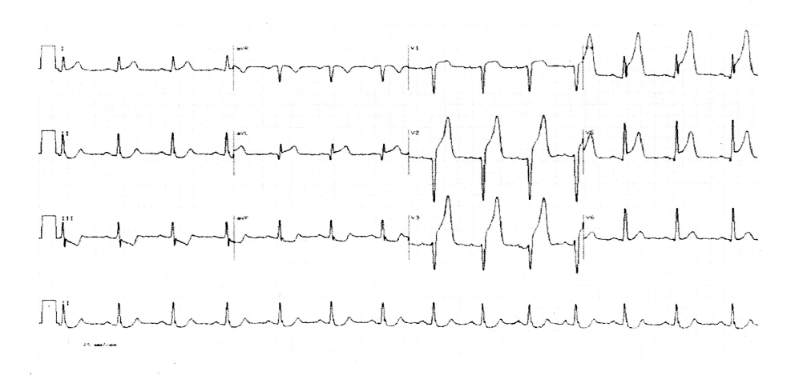

**ANSWER BENCHMARK**

**1. Fever syndrome of unknown origin: differential diagnosis**

FUO can be diagnosed with the simultaneous presence of 3 criteria: 1) persistent or repeatedly recurrent fever >38.3 °C; 2) fever lasts > 3 weeks; 3) the cause could not be determined or the diagnosis is unclear, despite routine diagnosis for ≈ 1 week. (≥3 days in hospital or ≥3 outpatient visits). In same, FUO may be diagnosed in another cases:

1. FUO which occurred during the patient's stay in the hospital (after 2 days of hospitalization), in a patient with neutropenia
2. FUO in a patient with progressive HIV infection, can be diagnosed if: a) fever >38.3 ° C persists or repeatedly recurs; b) it was not possible to determine the cause or the diagnosis is ambiguous, despite the usual diagnosis within 3-5 days in the hospital.

The most important causes of classical FUO are:

* infections
* autoimmune diseases
* malignant neoplasms
* medications
* others — cirrhosis and alcoholic hepatitis, recurrent pulmonary embolism (without severe clinical manifestations), inflammatory bowel diseases.

Causes depending on the risk group 1) FUO in a patient in a hospital 2) FUO in a patient with neutropenia 3) FUO in an HIV-infected person 4) FUO in a person returning from tropical regions

3. Fever characteristic: 1) septic fever, hectic (during the day one rapid increase in temperature, often up to ≈40 ° C, then a decrease, sometimes even to normal; the amplitude of daily fluctuations > 2 ° C) — abscess, miliary tuberculosis, lymphomas, leukemia; 2) two fever peaks per day — for example, the Still’s disease in adults, miliary tuberculosis, malaria, visceral leishmaniasis, gonococcal endocarditis of the right heart; 3) intermittent fever (periodic; recurrent fever rises with regular or irregular intervals after a relatively non-sporadic period; daily amplitude of fluctuations >2 ° C) — including malaria, lymphoma, leukemia, cyclic neutropenia; 4) continuous fever (daily amplitude of 38 °C and non-sporadic periods), brucellosis; 6) high fever: >39 °C — abscess, lymphoma and leukemia, systemic vasculitis, infection; >41 °C — medications and other chemicals, as well as artificially induced fever (the patient's condition is disproportionately good), damage to the central nervous system (neoplasm, injury, infection). 7) subchronic fever (≥6 months): most often idiopathic; granulomatous hepatitis, Still's disease in adults, sarcoidosis, Crohn's disease; less often — SLE, artificially induced fever. 8) recurrent FUO infections, tumors and systemic diseases. 9) relative bradycardia accompanying fever 10) recurrent clinically obvious chills associated with fever — bacterial infection (abscesses, bacteremia, septic thrombophlebitis, brucellosis), neoplasms (kidney cancer, lymphomas, leukemia), malaria.

4. Basic research methods for differential diagnosis:

1) laboratory tests — a general blood test with the formula of blood cells, ESR, procalcitonin (allows you to distinguish fever of infectious origin from non-infectious, especially in patients with neutropenia), electrolytes, bilirubin, liver enzymes, urea, creatinine, uric acid, general urine analysis, rheumatoid factor and antinuclear antibodies, microbiological studies: blood culture (3 times without antibiotics), urine culture, microbiological diagnostics of tuberculosis and mycobacteriosis, serological tests (HIV, CMV, EBV). Others are carried out depending on the suspected cause — direct or microscopic examination of the collected tissue, examination of cerebrospinal fluid, crops, antigen detection, serological tests, molecular studies. Imaging studies: ultrasound of the abdominal cavity, RG of the chest, FDG-PET CT, MRI of the abdominal cavity and pelvic organs (if necessary, also a head examination).

1. **Pneumonia. Etiology. Pathogenesis. Classification. Clinic. Differentialdiagnosis. Treatment**

Pneumonia is as an acute respiratory illness associated with recently developed radiological pulmonary shadowing that may be segmental, lobar or multilobar.

**Etiology**

Factors that predispose to pneumonia:

• Cigarette smoking

• Upper respiratory tract infections

• Alcohol

• Glucocorticoid therapy

• Old age

• Recent influenza infection

• Pre-existing lung disease

• HIV

• Indoor air pollution

Organisms causing community-acquired pneumoniaЖ

*Bacteria*

• Streptococcus pneumoniae

• Mycoplasma pneumoniae

• Legionella pneumophila

• Chlamydia pneumoniae

• Haemophilus influenzae

• Staphylococcus aureus

• Chlamydia psittaci

• Coxiella burnetii (Q fever)

• Klebsiella pneumoniae

(Freidländer’s bacillus)

*Viruses*

• Influenza, parainfluenza

• Measles

• Herpes simplex

• Varicella

• Adenovirus

• Cytomegalovirus

• Coronaviruses (SARS-CoV and MERS-CoV)

Most cases are spread by droplet infection, and while CAP may occur in previously healthy individuals, several factors may impair the effectiveness of local defences and predispose to CAP. Streptococcus pneumoniae remains the most common infecting agent, and thereafter the likelihood that other organisms may be involved depends on the age of the patient and the clinical context. Viral infections are recognized as important causes of CAP in children and their contribution to adult CAP is increasingly recognised. The common causativeorganisms are shownupper.

**Pathogenesis:**

• Patchy Areas of Acute Suppurative Inflammation → Patchy Consolidation

• Basal Lower Lobes Common (Due to gravity – bacteria settle in the lower lungs)

**Morphology:**

• Doesn’t follow anatomical boundaries – Often Multi-Lobar & Bilateral.

• Usually Bilateral Patchy Consolidation →Scattered Opacities on CXR

**Clinical features**

Pneumonia, particularly lobar pneumonia, usually presents as an acute illness. Systemic features, such as fever, rigors, shivering and malaise, predominate and delirium may be present. Pulmonary symptoms include cough, which at first is characteristically short, painful and dry, but later is accompanied by the expectoration of mucopurulent sputum. Rust-coloured sputum may be produced by patients with Strep. Pneumonia infection and the occasional patient may report haemoptysis. Pleuritic chest pain may be a presenting feature and on occasion may be referred to the shoulder or anterior abdominal wall. Upper abdominal tenderness is sometimes apparent in patients with lower lobe pneumonia or those with associated hepatitis. Less typical presentations may be seen in the very young and the elderly.

Mycoplasma pneumoniae is more common in young people and rare in the elderly, whereas aemophilus influenzae is more common in the elderly, particularly if underlying lung disease is present. Legionella pneumophila occurs in local outbreaks centred on contaminated cooling towers in hotels, hospitals and other industries. Staph. aureus is more common following an episode of influenza. Klebsiella pneumonia has a specific association with alcohol abuse and often presents with a particularly severe bacteraemic illness.

Clinical examination should first focus on the respiratory and pulse rates, blood pressure and an assessment of the mental state, as these are important in forming a judgement as to severity of the illness. Chest signs vary, depending on the inflammatory response, which proceeds through stages of acute exudation, red and then grey hepatisation, and finally resolution. When consolidated, the lung is typically dull to percussion and, as conduction of sound is enhanced, auscultation reveals bronchial breathing and whispering pectoriloquy; crackles are heard throughout. An assessment of the state of nutrition is important, particularly in the elderly. The presence of herpes labialis may point to streptococcal infection, as may the finding of ‘rusty’ sputum.

**Differential diagnosis of pneumonia**

• Pulmonary infarction

• Pulmonary/pleural tuberculosis

• Pulmonary oedema (can be unilateral)

• Pulmonary eosinophilia

• Malignancy: bronchoalveolar cell carcinoma

• Cryptogenic organising pneumonia/bronchiolitis obliterans organizing pneumonia (COP/BOOP)

**Management**

The most important aspects of management include **oxygenation, fluid balance and antibiotic therapy**. In severe or prolonged illness, nutritional support may be required.

Oxygen should be administered to all patients with tachypnoea, hypoxaemia, hypotension or acidosis with the aim of maintaining the PaO2 ≥ 8 kPa (60 mmHg) or SaO2 ≥ 92%. High concentrations (≥ 35%), preferably humidified, should be used in all patients who do not have hypercapnia associated with COPD. Continuous positive airway pressure (CPAP) should be considered in those who remain hypoxic despite high-concentration oxygen therapy, and these patients should be managed in a high-dependency or intensive care environment where mechanical ventilation may be rapidly employed.

Intravenous fluids should be considered in those with severe illness, in older patients and those with vomiting.

The initial choice of antibiotic is guided by clinical context, severity assessment, local knowledge of antibiotic resistance patterns and, at times, epidemiological information. In most patients with uncomplicated pneumonia a 5-day course is adequate, although treatment is usually required for longer in patients with Legionella, staphylococcal or Klebsiella pneumonia. Oral antibiotics are usually adequate unless the patient has a severe illness, impaired consciousness, loss of swallowing reflex or functional or anatomical reasons for malabsorption.

Uncomplicated CAP

• Amoxicillin 500 mg 3 times daily orally If patient is allergic to penicillin

• Clarithromycin 500 mg twice daily orally or Erythromycin 500 mg 4 times daily orally

If Staphylococcus is cultured or suspected

• Flucloxacillin 1–2 g 4 times daily IV plus

• Clarithromycin 500 mg twice daily IV

If Mycoplasma or Legionella is suspected

• Clarithromycin 500 mg twice daily orally or IV or Erythromycin 500 mg 4 times daily orally IV plus

• Rifampicin 600 mg twice daily IV in severe cases

Severe CAP

• Clarithromycin 500 mg twice daily IV or Erythromycin 500 mg 4 times daily IV plus

• Co-amoxiclav 1.2 g 3 times daily IV or Ceftriaxone 1–2 g daily IV or Cefuroxime 1.5 g 3 times daily IV or

• Amoxicillin 1 g 4 times daily IV plus flucloxacillin 2 g 4 times daily IV

**CURB-65**

Any of:

• Confusion*

• Urea > 7 mmol/L

• Respiratory rate > 30/min

• Blood pressure (systolic < 90 mmHg or diastolic < 60 mmHg)

• Age > 65 years

Score 1 point for each feature present

* 1. Score - Likely to be suitable for home treatment

2 score - Consider hospital-supervised treatment

Options may include

• Short-stay inpatient

• Hospital-supervised outpatient

3 and more score - Manage in hospital as severe pneumonia

Assess for ICU admission, especially if CURB-65 score = 4 or 5

**Clinical case**

1 Non-allergic bronchial asthma, moderate course, first detected, uncontrolled. Respiratory failure 1.

2. Examination plan: clinical blood test; ECG, spirometry; x-ray of the chest in two projections; general sputum analysis; consultation with a pulmonologist.

3. Treatment plan: smoking cessation; in order to stop an attack of the disease, inhalation use short-acting β2-adrenergic agonists (Salbutamol or Fenoterol). For permanent use - a combination of low doses of inhaled corticosteroids (Fluticasone 100-250 mcg / day, Budesonide 200-400 mcg / day or Beclomethasone dipropionate 200-500 mcg / day) with long-acting β2-agonists (Salmeterol 100 mcg / day or Formoterol 9 -18 mcg/day). Teachingasthmaself-managementskills.

**Интерпретация ЭКГ**

1The rhythm is regular, sinus.

Heart rate 90 beats per minute.

Electrical axis of the heart - normogram.

ST segment elevation is recorded in I, avL, V1-V6 leads , pathological Q wave - in V1-V3, discordant depression of the ST segment in II, III, aVF leads.

Conclusion. Acute, anterior widespread myocardial infarction with ST segment elevation.