Федеральное государственное бюджетное образовательное учреждение высшего образования

"Казанский государственный медицинский университет"

Министерства здравоохранения Российской Федерации

Кафедра госпитальной терапии

**Examination car dNo. 2**

1. Differential diagnosis of edema
2. Osteoarthritis. Classification. Clinical presentation. Differential diagnosis. Treatment

Заведующая кафедрой, д.м.н. Д.И. Абдулганиева

Федеральное государственное бюджетное образовательное

учреждение высшего образования

“Казанский государственный медицинский университет”

Министерства здравоохранения Российской Федерации

“Утверждаю”

Зав. кафедрой, д.м.н., профессор __________________Д.И. Абдулганиева

Clinical case №__

A 68-year-old man with long history of hypertension, diabetes, treated with losartan, amlodipine, metformin, cardioaspirin, presented with progressing worsening dyspnea.

Objectively: BP 200/100 mmHg, HR 130 bpm, BR 28/min, Sat 72%.

Arterial blood gases:

|  |  |  |
| --- | --- | --- |
|  |  | Normal range |
| pH | 7,20 | 7.35-7.45 |
| lactate | 3 mmol/L | < 1.0 mmol/L |
| PO2 | 60 mmHg | 75 -100 mmHg |
| pCO2 | 65 mmHg | 35-45 mmHg |
| HCO3- | 18 | 22-26 mEq/L |

Grace Risk Score was calculated - 168.

ECG: sinus tachycardia (130 bpm), diffuse ischemia (ST-segment depression in most leads).

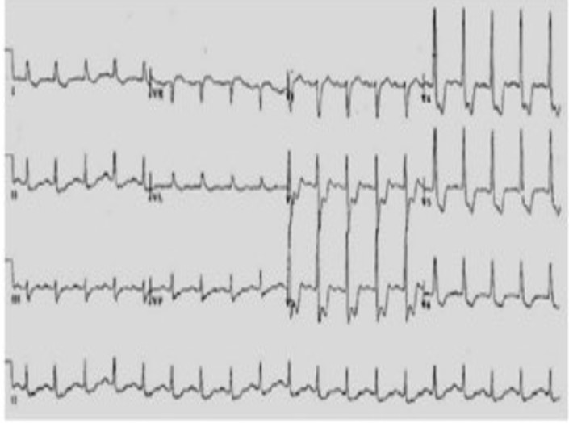

Chest X-Ray: diffuse signs of congestion, B kerley lines, enhanced lung hilus*,* enlarged cardiac silhouette.

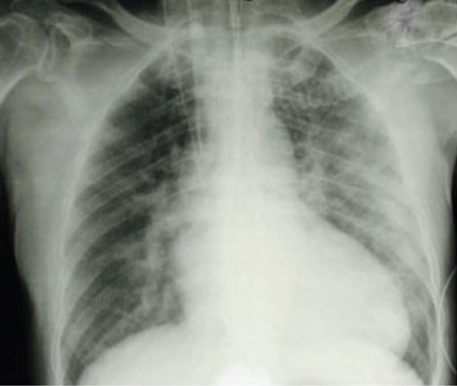

Echocardiography: dilatative cardiac decompensation, global reduction in contractility with specific apical hypomotility.

**Questions:**

1. Which emergency condition and its complication are presented in this case?
2. In light of those findings and of a Grace Risk Score of 168 which treatment must be started?

**ANSWER BENCHMARK**

**1. Differential diagnosis of edema**

Edema is an accumulation of fluid in the interstitial space that occurs as the capillary filtration exceeds the limits of lymphatic drainage, producing noticeable clinical signs and symptoms. The rapid development of generalized pitting edema associated with systemic disease requires timely diagnosis and management. The chronic accumulation of edema in one or both lower extremities often indicates venous insufficiency, especially in the presence of dependent edema and hemosiderin deposition. Skin care is crucial in preventing skin breakdown and venous ulcers. Eczematous (stasis) dermatitis can be managed with emollients and topical steroid creams. Patients who have had deep venous thrombosis should wear compression stockings to prevent postthrombotic syndrome. If clinical suspicion for deep venous thrombosis remains high after negative results are noted on duplex ultrasonography, further investigation may include magnetic resonance venography to rule out pelvic or thigh proximal venous thrombosis or compression. Obstructive sleep apnea may cause bilateral leg edema even in the absence of pulmonary hypertension. Brawny, nonpitting skin with edema characterizes lymphedema, which can present in one or both lower extremities. Possible secondary causes of lymphedema include tumor, trauma, previous pelvic surgery, inguinal lymphadenectomy, and previous radiation therapy. Use of pneumatic compression devices or compression stockings may be helpful in these cases.

The following laboratory tests are useful for diagnosing systemic causes of edema: brain natriuretic peptide measurement (for CHF), creatinine measurement and urinalysis (for renal disease), and hepatic enzyme and albumin measurement (for hepatic disease). In patients who present with acute onset of unilateral upper or lower extremity swelling, a d-dimer enzyme-linked immunosorbent assay can rule out DVT in low-risk patients. However, this test has a low specificity, and d-dimer concentrations may be elevated in the absence of thrombosis.

Venous ultrasonography is the imaging modality of choice in the evaluation of suspected DVT. Compression ultrasonography with or without Doppler waveform analysis has a high sensitivity (95%) and specificity (96%) for proximal thrombosis; however, the sensitivity is lower for calf veins (73%).Duplex ultrasonography can also be used to confirm the diagnosis of chronic venous insufficiency.

Lymph flow cannot be detected with ultrasonography. Therefore, indirect radionuclide lymphoscintigraphy, which shows absent or delayed filling of lymphatic channels, is the method of choice for evaluating lymphedema when the diagnosis cannot be made clinically. Patients with unilateral lower extremity edema who do not demonstrate a proximal thrombosis on duplex ultrasonography may require additional imaging to diagnose the cause of edema if clinical suspicion for DVT remains high. Magnetic resonance angiography with venography of the lower extremity and pelvis can be used to evaluate for intrinsic or extrinsic pelvic or thigh DVT. Compression of the left iliac vein by the right iliac artery (May-Thurner syndrome) should be suspected in women between 18 and 30 years of age who present with edema of the left lower extremity. Magnetic resonance imaging may aid in the diagnosis of musculoskeletal etiologies, such as a gastrocnemius tear or popliteal cyst. T1-weighted magnetic resonance lymphangiography can be used to directly visualize the lymphatic channels when lymphedema is suspected.

Echocardiography to evaluate pulmonary arterial pressures is recommended for patients with obstructive sleep apnea and edema. In one study of patients with obstructive sleep apnea, 93% of those with edema had elevated right arterial pressures. Pulmonary hypertension has long been thought to be the cause of edema associated with obstructive sleep apnea. However, one study found that although a high proportion of patients with edema had obstructive sleep apnea (more than two-thirds), nearly one-third of these patients did not have pulmonary hypertension, which suggests a stronger correlation between edema and obstructive sleep apnea than can be explained by the presence of pulmonary hypertension alone.

**2.Osteoarthritis. Classification. Clinical presentation. Differential diagnosis. Treatment**

Osteoarthritis (OA) is the most common form of arthritis in the world. It can be classified into 2 categories: primary osteoarthritis and secondary osteoarthritis. Classically, OA presents with joint pain and loss of function; however, the disease is clinically very variable and can present merely as an asymptomatic incidental finding to a devastating and permanently disabling disorder.

The presentation and progression of OA vary greatly from person to person. The triad of symptoms of OA is joint pain, stiffness, and locomotor restriction. Patients can also present with muscle weakness and balance issues.

Pain is typically related to activity and resolves with rest. In those patients in whom the disease progresses, pain is more continuous and begins to affect activities of daily living, eventually causing severe limitations in function. Patients may also experience bony swelling, joint deformity, and instability (patients complain that the joint is “giving way” or “buckling,” a sign of muscle weakness).

OA typically affects proximal and distal interphalangeal joints, first carpometacarpal (CMC) joints, hips, knees, first metatarsophalangeal joints, and joints of the lower cervical and lumbar spine. OA can be monoarticular or polyarticular in the presentation. Joints can be at different stages of disease progression. Typical exam findings in OA include bony enlargement, crepitus, effusions (non-inflammatory), and a limited range of motions. Tenderness may be present at joint lines, and there may be pain upon passive motion. Classic physical exam findings in hand OA include Heberden’s nodes (posterolateral swellings of DIP joints), Bouchard’s nodes (posterolateral swellings of PIP joints), and “squaring” at the base of the thumb (first CMC joints).

A thorough history and physical exam (with a focused musculoskeletal exam) should be performed on all patients, with some findings summarized above. OA is a clinical diagnosis and can be diagnosed with confidence if the following are present: 1) pain worse with activity and better with rest, 2) age more than 45 years, 3) morning stiffness lasting less than 30 minutes, 4) bony joint enlargement, and 5) limitation in range of motion. A differential diagnosis should include rheumatoid arthritis, psoriatic arthritis, crystalline arthritis, hemochromatosis, bursitis, avascular necrosis, tendinitis, radiculopathy, among other soft tissue abnormalities. Blood tests such as CBC, ESR, rheumatoid factor, ANA are usually normal in OA, although they may be ordered to rule out inflammatory arthritis. If the synovial fluid is obtained, the white blood cell count should be less than 2000/microL, predominantly mononuclear cells (non-inflammatory), which is consistent with a diagnosis of OA.

X-rays of the affected joint can show findings consistent with OA, such as marginal osteophytes, joint space narrowing, subchondral sclerosis, and cysts; however, radiographic findings do not correlate to the severity of disease and may not be present early in the disease. MRI is not routinely indicated for OA workup; however, it can detect OA at earlier stages than normal radiographs. Ultrasound can also identify synovial inflammation, effusion, and osteophytes which can be related to OA.

There are several classification systems for OA. In general, they include the effects on joints, the age of onset, radiographic appearance, presumed etiology (primary vs. secondary), and rate of progression. The American College of Rheumatology classification is the most widely used classification system. At this time, it is not possible to predict which patients will progress to severe OA and which patients will have their disease arrest at earlier stages.

Treatment goals for OA are to minimize both pain and functional loss. Comprehensive management of the disease involves both non-pharmacologic and pharmacologic therapies. Typically, patients with mild symptoms can be managed by the former, while more advanced diseases need a combination of both.

Mainstays for non-pharmacologic therapy include 1) avoidance of activities exacerbating pain or overloading the joint, 2) exercise to improve strength, 3) weight loss, and 4) occupational therapy for unloading joints via brace, splint, cane, or crutch. Weight loss is a critical intervention in those who are overweight and obese; each pound of weight loss can decrease the load across the knee 3 to 6-fold. Formal physical therapy can immensely assist patients in using equipment such as canes appropriately while also instructing them on exercises. Exercise programs that combine both aerobic and resistance training have been shown to decrease pain and improve physical function in multiple trials and should be encouraged by physicians regularly. Malalignment of joints should be corrected via mechanical means such as realignment knee brace or orthotics.

Pharmacotherapy of OA involves oral, topical, and/or intraarticular options. Acetaminophen and oral NSAIDs are the most popular and affordable options for OA and are usually the initial choice of pharmacologic treatment. NSAIDs are usually prescribed orally or topically and, initially, should be started as needed rather than scheduled. Due to gastrointestinal toxicity, and renal and cardiovascular side effects, oral NSAIDs should be used very cautiously with close monitoring long term. Topical NSAIDs are less efficacious than their oral counterparts but offer fewer gastrointestinal and other systemic side effects; however, they often cause local skin irritation.

Intraarticular joint injections can also be an effective treatment for OA, especially in a setting of acute pain. Glucocorticoid injections have a variable response, and there is ongoing controversy regarding repeated injections. Hyaluronic acid injections are another option, but their efficacy over placebo is also controversial. Notably, there is no role for oral glucocorticoids.

Duloxetine has modest efficacy in OA; opioids can be used in those patients without an adequate response to the above and who may not be candidates for surgery or refuse it altogether.

It is important to note that patients vary greatly in their response to treatment, and there is a large component of trial and error in selecting the agents that will be most effective. In those patients specifically with knee or hip OA who have failed multiple non-pharmacologic and pharmacologic treatment modalities, surgery is the next option. Failure rates for both knee and hip replacements are quite low, and they can provide pain relief and increased functionality. The timing of surgery is key to predict success. Very poor functional status and considerable muscle weakness may not lead to improved postoperative functional status versus those undergoing surgery earlier in the disease course

Differentials include:

* Rheumatoid arthritis
* Psoriatic arthritis
* Crystalline arthritis
* Bursitis
* Tendinitis
* Hemochromatosis
* Avascular necrosis
* Radiculopathy
* Other soft-tissue conditions

**Clinical case**

1 Diagnosis: MI, acute phase, complicated by pulmonary edema.

Treatment. Depending on the severity of the condition and the reason for the pulmonary edema, treatment might include one or more of the following medications:

* **Diuretics.** Diuretics, such as furosemide (Lasix), decrease the pressure caused by excess fluid in the heart and lungs.
* **Blood pressure drugs.** These help manage high or low blood pressure, which can occur with pulmonary edema. A provider may also prescribe medications that lower the pressure going into or out of the heart. Examples of such medicines are nitroglycerin (Nitromist, Nitrostat, others) and nitroprusside (Nitropress).
* **Inotropes.** This type of medication is given through an IV for people in the hospital with severe heart failure. Inotropes improve heart pumping function and maintain blood pressure.
* **Morphine (MS Contin, Infumorph, others).** This narcotic may be taken by mouth or given through an IV to relieve shortness of breath and anxiety. But some care providers believe that the risks of morphine may outweigh the benefits. They're more likely to use other drugs.

**Интерпретация ЭКГ**

1The rhythm is regular, sinus.

Heart rate 130 beats per minute.

Electrical axis of the heart - normogram.

Diffuse ischemia (ST-segment depression in most leads).